How to Run/Test application.

1. Unzip the project and load/reload all maven dependency
2. You should be able to start the example application by executing com.freenow.FreeNowServerApplicantTestApplication, which starts a webserver on port 8080 (<http://localhost:8080> ) and serves SwaggerUI where can inspect and try existing endpoints.

H2-Database url: <http://localhost:8080/h2-console>

Swagger-UI url: <http://localhost:8080/swagger-ui.html>

NOTE: Once you access swagger url , it asks for use username and password. Just click Cancel.

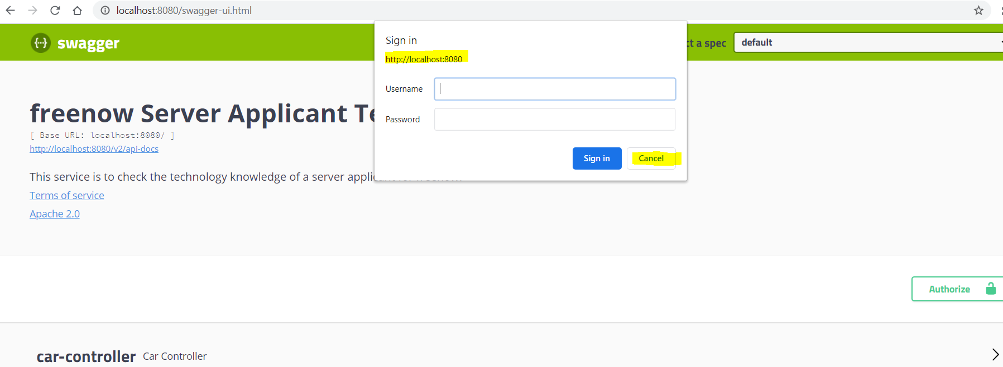

1. User details:

username password role api access

driver01 Test@123 ROLE_DRIVER /v1/drivers & /v1/drivers/**

admin01 Test@123 ROLE_ADMIN all api access

1. Click on Authorize button on swagger HTML file

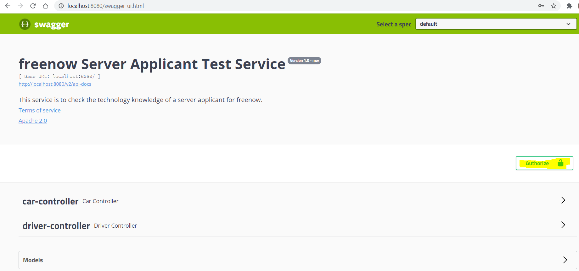

1. And insert correct user details and click Authorize button.

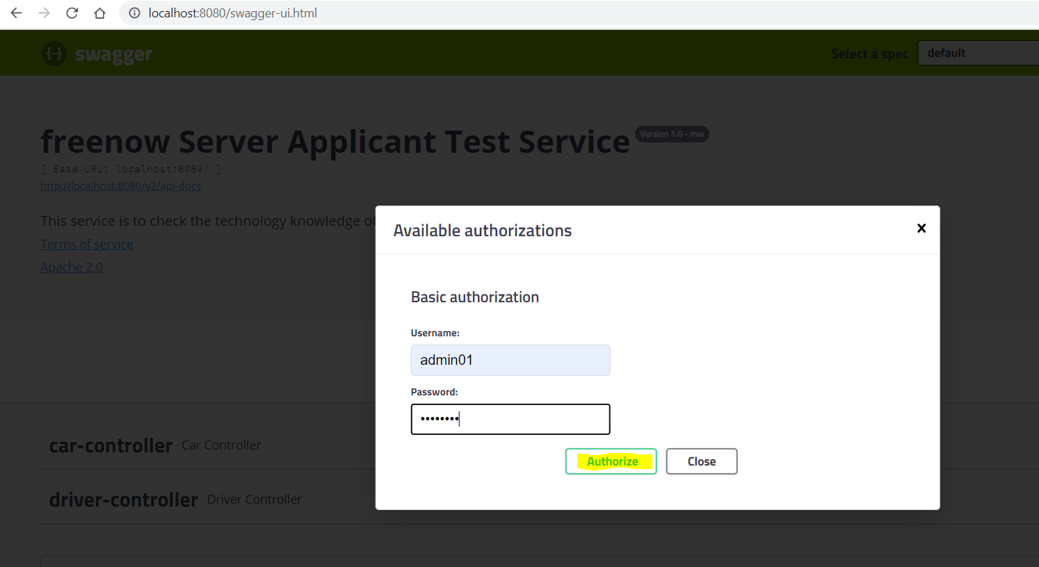

1. From POSTMAN

